

CISCO

COMMAND LINE



SUBASH SUBEDI

Table of Contents

1. Types of Mode 2

2. CMD to Enter User EXEC Mode. 2

3. CMD to Enter Privileged EXEC Mode. 2

4. CMD to Enter Global Configuration Mode. 2

5. CMD to Change the device name. 2

6. CMD to Set the Manual Time Settings. 3

7. CMD to Set the Automatic Time Settings. 3

8. CMD to save all configurations. 3

9. CMD to review or see the latest NVRAM file of the network node 5

10. CMD to disable translating unfamiliar words (typos) into IP addresses. (Shift+Ctrl+6) 6

11. CMD to set Banner Message at Starting. 6

12. CMD to set Normal Enable Password (to Enter Privileged EXEC Mode). 6

13. CMD to set Encrypt the plain text passwords. 7

14. CMD to set time Disconnect/Logout automatically. 8

15. CMD to configure the console cable access password 9

16. CMD to configure password while access through TELNET and SSH 10

17. CMD to view LAN interface status (UP/Down) 12

18. CMD to set an IP address in interface 12

19. CMD to set trunk port 13

20. CMD to view VLAN 14

21. CMD to create VLAN in SWITCH AND ROUTER 14

22. CMD to add vlan on interface from range like 1-12 vlan-10 and 13-24 vlan 25 15

23. CMD to assign IP address in interface vlan 16

# Types of Mode

User EXEC Mode (>).

Privileged EXEC Mode (#).

Global Configuration Mode (config).

Interface Configuration Mode (config-if).

Line Configuration Mode (config-line).

V LAN Configuration Mode (config-vlan)

# CMD to Enter User EXEC Mode.



Figure

>

# CMD to Enter Privileged EXEC Mode.

>enable



Figure

# CMD to Enter Global Configuration Mode.

#configure terminal

Figure

# CMD to Change the device name.

hostname [Name of Router]

Figure

# CMD to Set the Manual Time Settings.

clock set [hh:mm:ss] [month] [day] [year] ***“This cmd is used in Privileged Exec Mode”***

Figure

do clock set [hh:mm:ss] [month] [day] [year] ***“This cmd is used in Global Configuration Mode”***

Figure

# CMD to Set the Automatic Time Settings.

clock timezone NPT 5 45

# CMD to save all configurations.

write memory ***“This cmd is used in Privileged Exec Mode”***

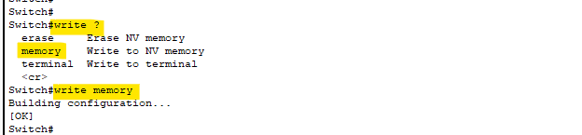

Figure

**OR**

wr ***“This cmd is used in Privileged Exec Mode”***



Figure

**OR**

copy running-config startup-config ***“This cmd is used in Privileged Exec Mode”***

Figure

**OR**

do write memory ***“This cmd is used in Privileged Exec Mode”***

Figure

**OR**

do wr ***“This cmd is used in Global Configuration Mode”***

Figure

**OR**

do copy running-config startup-config ***“This cmd is used in Global Configuration Mode”***

Figure

# CMD to review or see the latest NVRAM file of the network node

show running-config

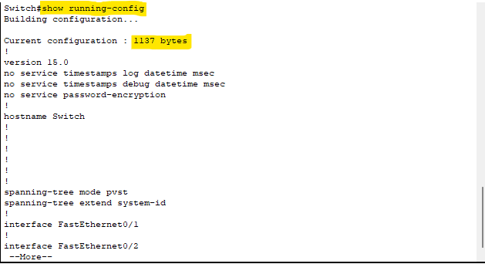

Figure

**OR**

do show running-config ***“This cmd is used in Global Configuration Mode”***

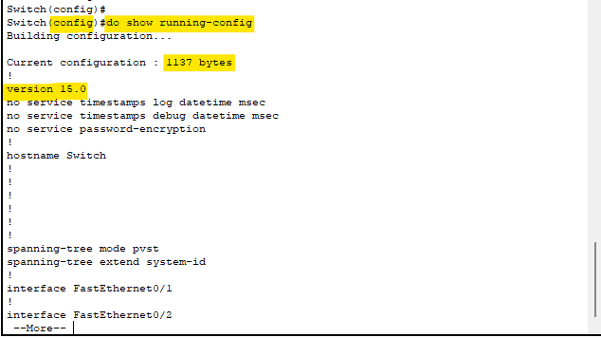

Figure

# CMD to disable translating unfamiliar words (typos) into IP addresses. (Shift+Ctrl+6)

no ip domain-lookup

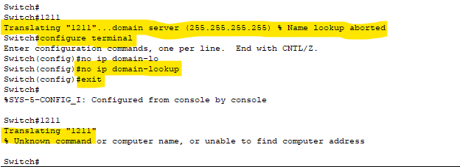

Figure

# CMD to set Banner Message at Starting.

banner motd $ [Write your message to display] $



Figure

# CMD to set Normal Enable Password (to Enter Privileged EXEC Mode).

enable password [ENTER YOUR PASSWOD]

Figure

RESULT



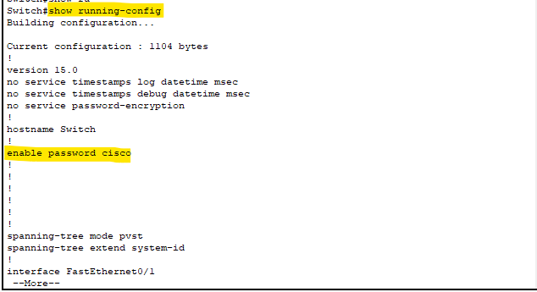

Figure

# CMD to set Encrypt the plain text passwords.

service password-encryption

Figure

RESULT

Figure

# CMD to set time Disconnect/Logout automatically.

It will be used when we are accessing the router through console cable.

line console 0

exec-time [Minutes] [Second]

exit

Figure

**ANOTHER**

It will be used when we are accessing the router through TELENET and SSH

line vty 0 15

exec-timeout [Minutes] [Second]

exit

Figure

# CMD to configure the console cable access password

This cmd is used for one password by many users.

line console 0

password [Enter your password]

login local or login

exec-time [Minutes] [Second]

exit

Figure

**ANOTHER**

This cmd is used as per username and password.

username [Name] secret [Enter your Password]

line console 0

login local or login

exec-time [Minutes] [Second]

exit

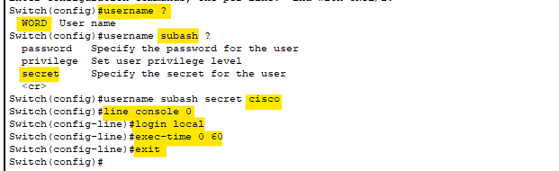

Figure

# CMD to configure password while access through TELNET and SSH

TELNET

line vty [] []

transport input telnet

login local

exec-time [Minutes] [Second]

exit

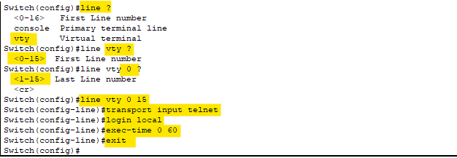

Figure

TELNET in per username and password

username [Name] secret [Enter your Password]

line vty 0 15

transport input telnet

login local

exec-time [Minutes] [Second]

exit

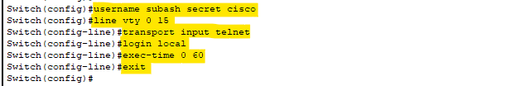

Figure

SSH

SSH in per username and password

username [Name] secret [Enter your Password]

ip domain-name [Nomain Name]

crypto key generate rsa

[Enter the rsa Number for encryprtion ]

ip ssh version [Enable SSH version ]

line vty [] []

login local

transport input ssh

exit

ip ssh time-out [Second] [Minutes]

ip ssh authentication-retries [Limit login attempts]

exit

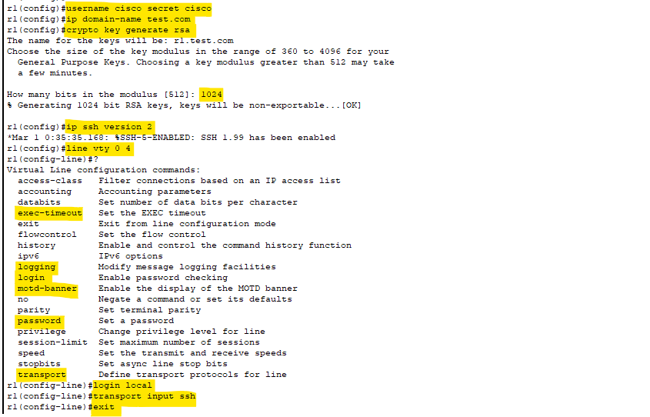

Figure

Figure

# CMD to view LAN interface status (UP/Down)

show interfaces status

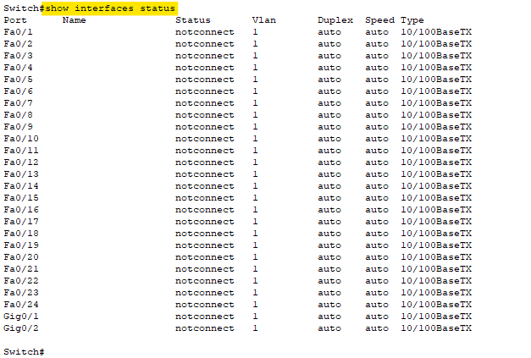

Figure

# CMD to set an IP address in interface

interface gigabitEthernet [interface number ]

ip address A.B.C.D IP subnet mask

no shutdown

exit

# CMD to set trunk port

configure terminal

interface GigabitEthernet0/1

switchport mode trunk

switchport trunk allowed vlan all

exit

Figure

# CMD to view VLAN

show vlan brief

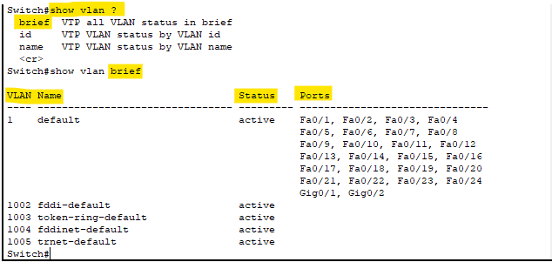

Figure

# CMD to create VLAN in SWITCH AND ROUTER

CREATE VLAN IN SWITCH AND ROUTER

vlan [Enter your vlan numebr]

name [Enter vlan name]

vlan 20

name TECHNICAL

Figure

RESULT

Figure

# CMD to add vlan on interface from range like 1-12 vlan-10 and 13-24 vlan 25

interface range gigabitEthernet [From]-[To ]

description [describe the port]

switchport mode access

switchport access vlan [NUMBER]

exit

**EXAMPLE**

interface range gigabitEthernet 1/0/13-24

description TECHNICAL SECTION

switchport mode access

switchport access vlan 500

exit

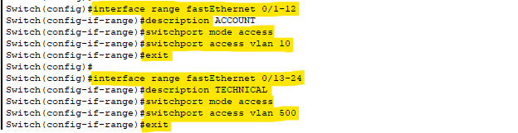

Figure

**RESULT**

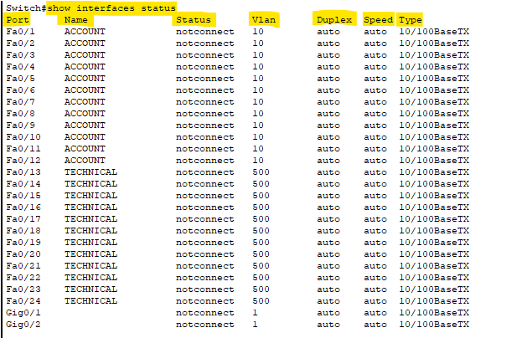

Figure

# CMD to assign IP address in interface vlan

interface vlan [Vlan Number]

ip address A.B.C.D IP subnet mask

arp Set arp type (arpa, probe, snap) or timeout

description Interface specific description

exit Exit from interface configuration mode

ip Interface Internet Protocol config commands

no Negate a command or set its defaults

shutdown Shutdown the selected interface

standby HSRP interface configuration commands

exit

**EXAMPLE**

Interface vlan 10

ip address 192.168.1.1 255.255.255.0

description $This Example of ip assign in vlan$

no shutdown

exit

